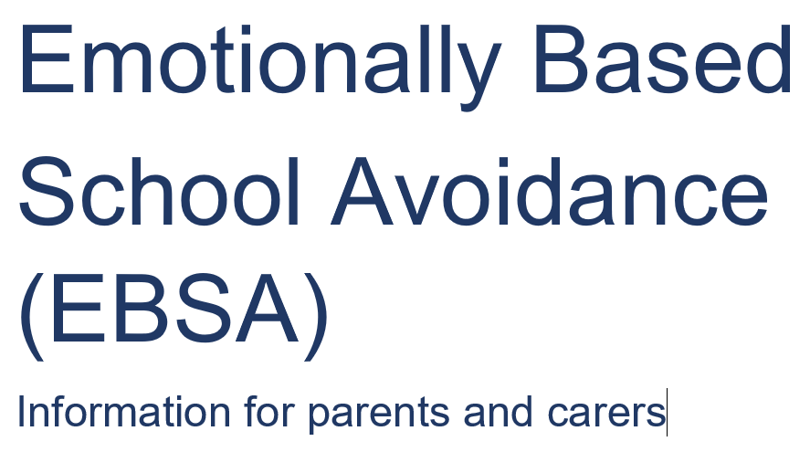

What is EBSA?
Insert definition from Wakefield School EBSA Booklet

Is your child worried about going to school?
It is very important to try to help children and young people overcome these difficulties as soon as possible. Absences mean that children miss out on learning and friendships, making it even more difficult when they come back. The diagram below shows how EBSA behaviours can develop.

The diagram below shows how EBSA behaviours can develop.

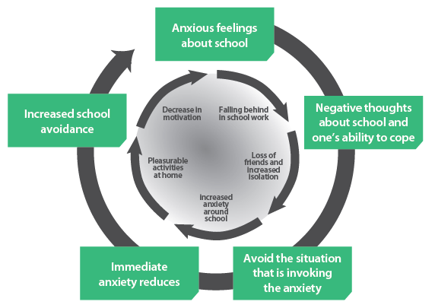

The longer the problems remain unaddressed the more difficult it becomes to change the school avoiding behaviour.

Signs of EBSA
These could include:
- Fearfulness, anxiety, tantrums or expression of negative feelings, when faced with the prospect of attending school.
- Complaining that they have abdominal pain, headache, sore throat, often with no signs of actual physical illness.
- Complaining of a racing heart, shaking, sweating, difficulty breathing, butterflies in the tummy or nausea, pins and needles and other physical signs they might be anxious.

These signs are usually worse on weekday mornings and absent at weekends and school holidays.

What should you do?
One of the most important ways you can support your child is to calmly listen to them and acknowledge that their fears are real to them. Remind them how important it is to attend school and reassure them that you and the school will work with them to make school a happier place for them.

Let the school know there is a problem as soon as possible and work in partnership with the school to address the issue. A plan should be made with the school to help your child. When you start to put the plan in place, your child may appear more unhappy and you should be prepared for this. It is really important that all adults both at home and school work together to agree a firm and consistent approach, and a positive ‘united front’ is recommended. Concerns about the plan should not be shared with your child.

It should be anticipated that there may be difficulties implementing the plan and when this happens solutions should be found. Try to be optimistic – if your child does not attend school one day, start again the next day. Remember that it likely to be more difficult after the weekend, a school holiday or a period of illness.

You may be tempted to change schools, however, research indicates that often difficulties will re-emerge in a new school. Therefore, wherever possible, it is better to resolve the issue in your child’s current school.

Finally, it is very important that throughout your child has someone to talk to. This could be a family member, friend someone in school or an organisation such as those listed at the end of the leaflet.

Listen to you and your child and acknowledge the difficulties faced by your child and you as a parent/carer.
- Keep in touch with you and your child even during extended periods of non-attendance.
- Work in partnership with you and your child to find ways of overcoming any difficulties so as to improve your child’s atte3ndance.
- Work together to develop a plan to support your child back into school.
- Consider the support your child might need when they arrive at school. This might include:
- Meeting a friend or key adult.
- Going to a quiet space to settle before school starts.
- Having responsibility e.g. a monitor role.
- Meet with school regularly to review the plan, celebrating the progress made and making modifications to the plan if needed.

Talking to your child about their worries
It is likely that your child will be anxious when they are asked to talk about returning to school. If they find it difficult to talk, you could ask them specific questions to help them to sort through their fears and feelings, remembering to also highlight the positives. For example:

What three things are you are you most worried about?
What three things do you like about school?

If your child finds it hard to tell you face to face they may prefer to write it down, email or text you or draw a picture to show you how they feel.

We have also produced an information booklet for young people.

Further sources of support.

Have a parent helpline – calls are free Mon-Fri 9.30am – 4pm
0808 802 5544
Website: https://youngminds.org.uk/contactus/parents-helpline-enquiries/

Wakefield Early Support Advice Information and Liaison (WESAIL)
Wakefield Early Support, Advice,Information and Liaison (WESAIL) provides a free, confidential and impartial service offering information covering a range of matters relating to Special Educational Needs and/or Disabilities (SEND).The aim of the WESAIL service is to support children, young people, their parents, carers and families by providing information to navigate systems and processes so that they can play an active role in decision making about matters relating to their or their children's health, education, social care to support and empower them in meeting their child's needs and promoting self-advocacy.
WESAIL can be contacted Monday to Friday 9 – 5 pm.
- Telephone: 07961 897036
- Email: WESAIL@barnardos.org.uk
- Website: https://barnardossendiass.org.uk/wakefield-sendiass/
- Like our Facebook page: Wesail Wakefield
- Address: Barnardo’s Wakefield Services, Room 249, Castleford Civic Centre, Ferrybridge Road, Castleford, WF10 4JH

